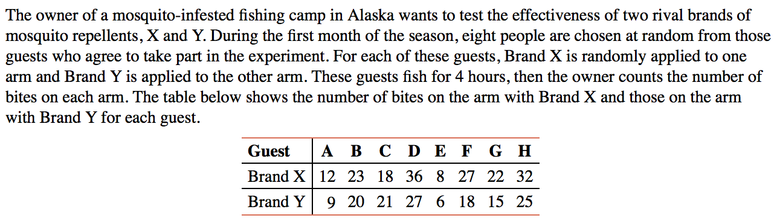

Your only assumption here is that the population statistic has a normal distribution.

